Superior University, Lahore (Gold Campus)

**SEMESTER PROJECT PROPOSAL**

**Ball Game**

**Group - 16**

Inam UL Hassan 219

Ukasha Zaheer 052

Kinza Batool 293

M. Huzaifa 374

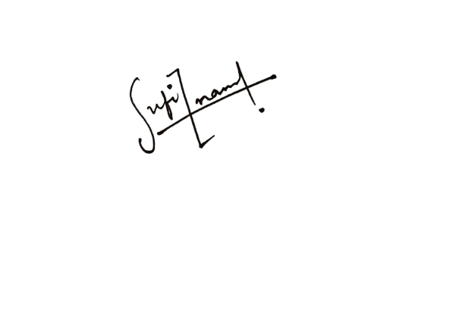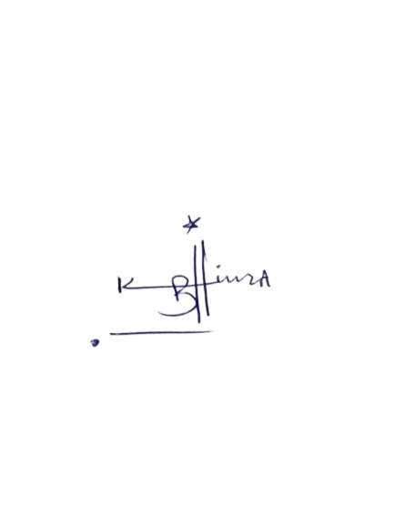

**Signatures of Group Members**

**TABLE OF CONTENTS:**

Introduction 3

Objectives  3

Functionalities Of The Project 3

Time Table 3

Flow Chart 4

Evaluation  4

Summary 4

# 1.Introduction

One of the first tennis sports games in arcades was called as **Pong** and also commonly known as **Ball Game**. It had basic two-dimensional visuals.

We'll utilize classes, objects, inheritance, and other OOP concepts in our C++ implementation of the game. We will use this project to put the OOP ideas we have learnt in class during practice.

# 2.Objectives

Following are some main objectives of the pong game project that should be the main focus involving to make this game**:**

* To create and build a C++ “Ball game”.
* To implement OOP ideas in a practical project.
* To illustrate how to comprehend and use C++'s classes, objects, and inheritance.

# 3.Functionalities of the Project

Some of the major functionalities of the project are as follows:

* A ball and two paddles will be used in this game. The player can raise and lower each paddle.
* The ball will go across the screen, bouncing against the top and bottom of the screen as well as the paddles.
* When a player misses the ball with their paddle, they score a point.
* In the game, the score will be tracked and shown on the screen.

# 4.Time Table

|  |  |  |
| --- | --- | --- |
| **Phases** | **Description of Work** | **Start and End Dates** |
| Phase One | Designing the game | [8th Week] - [10th Week] |
| Phase Two | Implementing the game’s logic | [11th Week] - [12th Week] |
| Phase Three | Testing and finalizing the game | [13th Week] - [16th Week] |

**5.Flowchart**

To start a project, the basic strategies are required. So, here a brief flowchart is given to explain the steps to be involved in the execution of our project.

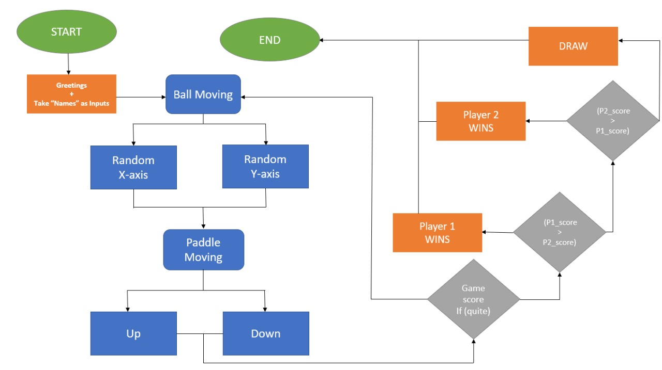

**6.Evaluation**

The conclusion of each project phase will serve as the basis for evaluating the project's progress.

The game's functionality, the way OOP ideas are applied, and the code quality will all be taken into account when determining the final assessment.

# 7.Summary

Our project is a C++ implementation of the “Ball game” that uses Object-Oriented Programming (OOP) techniques. Players will be able to manipulate paddles to hit a ball back and forth in this game.

The intention is to offer an entertaining and captivating method of showcasing the strength and adaptability of OOP.